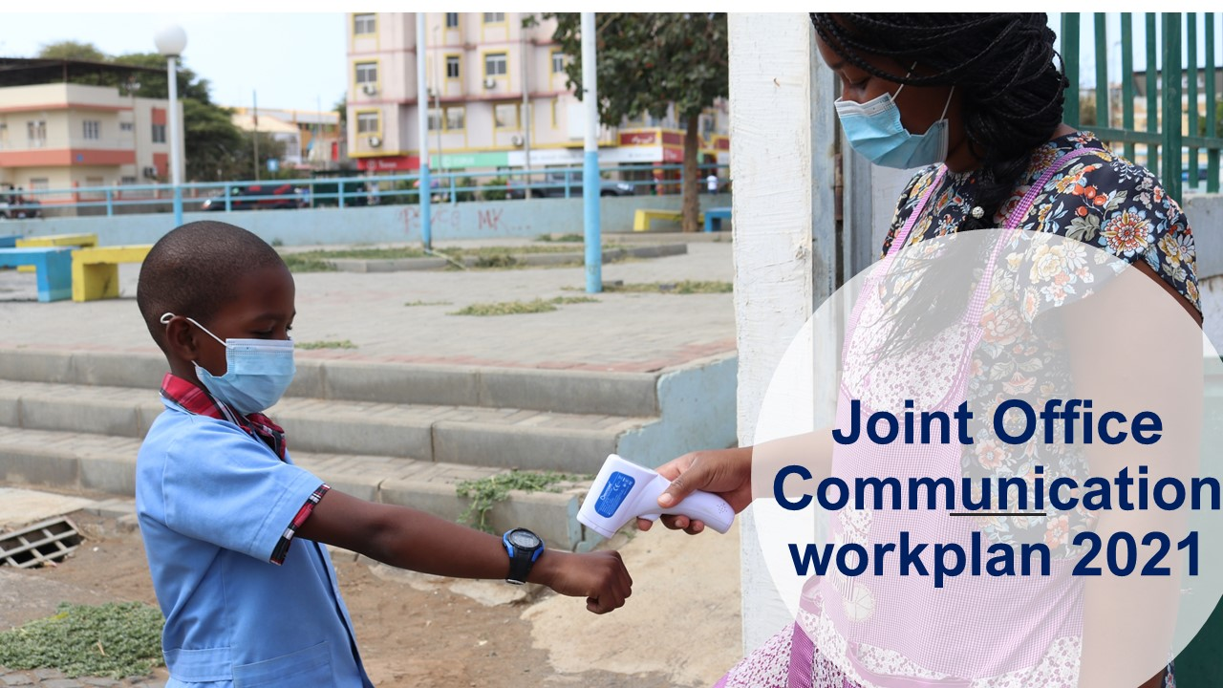

Joint Office Communication workplan 2021

Key results | Expected output | activity | Time | Lead Unit/Agency/Portfolios | Financial costs (USD) | Performance’s indicators
1.The new visual identity of the Joint Office is created and implemented | a) New logo created, shared and adopted by All Staff JO *  b) Reformulation of the mission, vision and values of the JO*  graphic standards manual produced and disseminated  c) The JO website is created and operationalized  d) Keep up a strong and solid presence on social and digital media  e) producing of Visibility materials  f) creation of a UNDP, UNFPA, UNICEF image database** | Hiring a consultancy for the rebranding of the Joint Office:  - creation of the new logo; review of the JO´s mission, vision, and values  Hiring a consultancy for design the website layout  Consolidate the FB and create an Instagram  Hiring company for the production of materials  Hiring a photograph | April/May  During the year |  | 2,500.00 USD  13,500.00 USD  5,000.00 USD  2,000.00 USD | JO Instagram
Sub Total 41,000. 00 USD
2.Effective Joint Office´s Visibility increased:  Enhance visibility by communicating the concrete development results, included the JO response to COVID/19 and recovery process  Donor and partner visibility promoted | a) The activities of the agencies are referenced and disseminated, on external channels, for example at the regional level UNDP, UNFPA an UNICEF communication channels  b) ) The activities of the agencies are referenced and disseminated through the JO newsletter, social media  a) Keeping donor community informed on the efficient use of provided funds  b)Keeping key audiences informed on the contributions of donor community  c)Mainstream donor and partner visibility rules into communication activities of relevant projects | Produce and send articles, pictures, videos and small stories with best practices  Produce and disseminate 4 newsletters, one of them special on gender equality and empowerment  sending information: newsletter, sharing content and photos published on social networks and website | During the year  April, July, out, dec  During the year |  | 6,000.00 USD  1,000.00 USD
Sub Total 7,000.00
3.Media, partners, society, institutions, understand and reports the JO work and the delink process | Media and communication advisors knowledge about the Joint Office ‘structure and work improved: the delinking process, present structure of the JO, the agencies and their respective mandates, the CV Program and they know how to know the dilink well and how to separate the JO from the United Nations Coordination  National partners knowledge about the Joint Office is improved and they know how to know the delink well and how to separate the JO from the United Nations Coordination | training session with journalists and fieldtrip to a project financed with Program´s funds  Held a short information session during the meeting with the partners | June/july  June/july | CA with support of Proj. Local Development | 3,000.00 USD
4. . Advocacy and promotion of SDGs: The SDGs are known by the population, partners, media | the SDGs are appropriated by the population trough effective actions and the media, which wrote articles about them | Organize a quiz on SDG to engage young people  highlight 2 SGD per month: Production of one small story video and photo story on each SDG  Identifying the best stories and individual or community on SDG  Create linkage between SDGs and key development results of portfolios. | During the year  During the year | UNCG Team | 5,000.00 USD
Sub Total 8,000.00 USD
5. Important dates related with the Agencies mandate celebrated | society takes notice and gets involved in the celebration of the dates:  World Population Day  International Youth Day  International Day of Democracy  International Day for the  Eradication of Poverty  International Children Day  Human Rights Day |  | July  August  September  October  November  December | UNFPA—SRHR and Population  Portfolio of Youth  Portfolio of Governance  Portfolio of Employment, Inclusive Growth  UNICEF  UNFPA—SRHR
TOTAL 56,000.00
* Proposals to be discussed with the staff
** it is necessary to create a high resolution image bank to be used, preventing us from using photos that are not ours. These photos will be used with the articles, stories, reports that are created and disseminated on our channels.

